Lyons Lu

Apr 30, 2020

Info330

Assignment 05

Database Design

# Introduction

In this paper I will be going over two database design questions with the instructional help of Randal Root, our Professor. The questions are why constraints, views, functions and stored procedures are recommended features of a professional database design and Explain how transaction statements are used in a stored procedure***.*** I will answer these questions with my observation and experience while doing this assignment. I hope this will help future programmers who are interested in database designs.

# Constraints, Views, Functions and Stored Procedures

The first question explains why constraints, views, functions and stored procedures are recommend features of a professional database design.

## Constraints

In the database design, we use constraints to set rules for every table. Constraints such as check could be used to restrict the data type, for example the input value of price should be non-negative values. We also use the constraints to set the attribute for each table such as primary key and foreign key. The advantage of using constraints is to build concise, reliable tables. Figure 1.

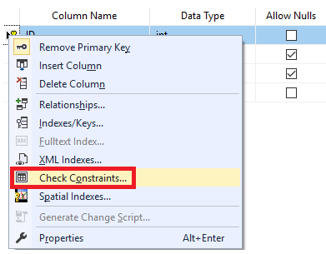

Figure 1: Check Constraints

## Views

In the database design, we use views to hide implement details from our clients. Although there is no obvious difference between tables and views, we use views as an abstraction layer to present our data and stored query on the data. The advantage of using a view is that we can restrict access to the table while allowing access to the view and avoid future changes for application development in our codes for our table.

## Functions

In the database design, we have many functions to use such as ISNULL, Max, Count, and Sum. These functions are great time-saver and pretty handy to use. We could also customize our own functions - the user defined functions. These functions are compiled and execute every time whenever it is called. User Defined Functions are simpler to invoke than Stored Procedures from inside another SQL statement. (*DATABASEJOURNAL*,<https://www.databasejournal.com/features/mssql/article.php/3348181/User-Defined-Functions-in-Microsoft-SQL-Server-2000.htm>)(External site).

## Stored Procedures

In the database design, stored procedures are pre-compiled and once compiled, they could be reused many times. Stored procedures can print or select data while views and functions can only use select. Passing the parameters into stored procedure and it will return the values based on the parameters. Figure 2.



Figure 2: Stored Procedures

# Transactions in Stored Procedures

The second question explains how transaction statements are used in a stored procedure

## Transactions

The transactions also known as explicit transactions are customized ‘logical unit of work’ and we treat entire block as a single event. It often starts with Begin Tran and ends with Commit Tran. We usually put transactions in stored procedures with try-catch block to catch errors. Figure 3.

Figure 3: Stored Procedures with Transactions

# Summary

Database design involves with use of views, functions, store procedures and constraints. Before we use them, we should think about what’s the best choice in design for the sake of our clients. Beyond that, we should think about efficiency and memory use.